

2022

Handout Praktikum Struktur Data

Nama :

Nim :   
Kelas :

***Program Studi S1 Sistem Informasi Fakultas Ilmu Komputer Universitas AMIKOM Yogyakarta***

*Disclaimer*

Hanya dipergunakan di Lingkungan Internal Universitas AMIKOM Yogyakarta

Penilaian

|  |  |  |
| --- | --- | --- |
| **Disusun Oleh** | **Diperiksa** **&**  **Oleh** | **Nilai dan Keterangan** |
| Ali Mustopa |  |  |
| Tgl. 17 September 2022 | Tgl. | Tgl. |

# MATERI 2 ARRAY (LARIK)

# Tujuan Instruksi Khusus

Mahasiswa diharapkan mampu:

* + 1. Menjelaskan pengertian *array*
    2. Menulis pendeklarasian *array*
    3. Menerapkan *array* dalam bahasa C++
    4. Mendemonstrasikan program menggunakan *array* 1dan 2 dimensi

# Dasar Teori

Array adalah suatu tipe data terstuktur yang berupa sejumlah data sejenis (bertipe data sama) yang jumlahnya tetap dan diberi suatu nama tertentu, elemen-elemen array tersusun secara berderet dan dapat diakses secara random di dalam memori. Array memiliki alamat yang besebelahan/berdampingan tergantung lebar tipe datanya dan dapat berupa array 1 dimensi, 2 dimensi, bahkan n-dimensi. Elemen-elemen array bertipe data sama dan bisa berisi nilai yang sama atau berbeda-beda.

Elemen-elemen array dapat diakses oleh program menggunakan suatu indeks tertentu secara random ataupun berurutan. Pengisian dan pengambilan nilai pada indeks tertentu dapat dilakukan dengan mengeset nilai atau menampilkan nilai pada indeks yang dimaksud. Dalam C++, tidak terdapat *error handling* terhadap batasan nilai indeks, apakah indeks tersebut berada di dalam indeks array yang sudah didefinisikan atau belum. Hal ini merupakan tanggung jawab programmer, sehingga jika programmer mengakses indeks yang salah, maka nilai yang dihasilkan akan berbeda atau rusak karena mengakses alamat memori yang tidak sesuai.

Deklarasi Array secara umum :

# tipe_data nama_var_array [ukuran];

Keterangan :

tipe_data : menyatakan jenis tipe data elemen larik (int, char, float, dll) nama_var_array : menyatakan nama variabel yang dipakai.

ukuran : menunjukkan jumlah maksimal elemen larik.

# Latihan

Cobalah beberapa program di bawah ini!

# Latihan 2.1.cpp

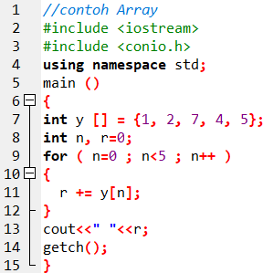

Jelaskan script Latihan 2.1.cpp di atas :

________________________________________________________________________  
________________________________________________________________________

________________________________________________________________________

________________________________________________________________________

Jelaskan Hasil Output script Latihan 2.1.cpp di atas :

________________________________________________________________________

________________________________________________________________________

**Latihan 2.2.cpp**

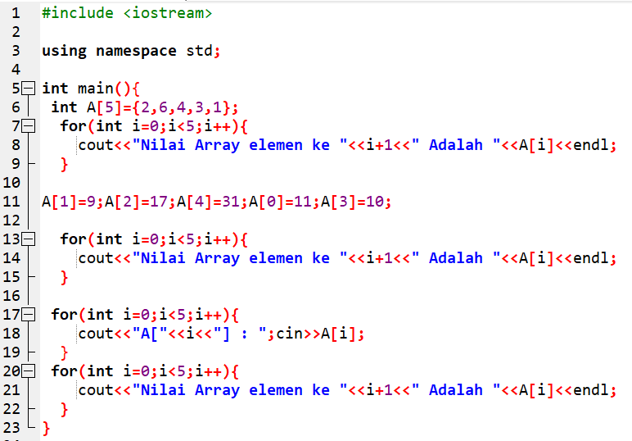

Jelaskan script Latihan 2.2.cpp di atas :

Jelaskan maksud baris 6 : ________________________________________________________________________  
________________________________________________________________________

Jelaskan maksud baris 11 : ________________________________________________________________________

________________________________________________________________________

Jelaskan maksud baris 17-19 : ________________________________________________________________________

________________________________________________________________________

**Latihan 2.3.cpp**

Perbaiki script Latihan 2.3.cpp sehingga menjadi output dibawahnya :

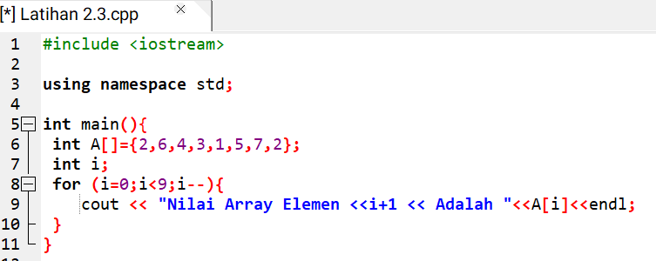

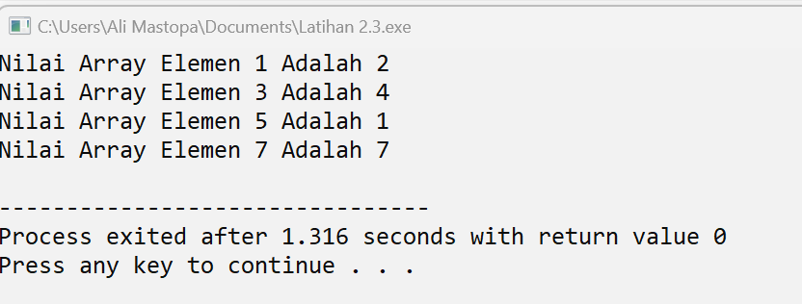

Jelaskan Perbaikan yang anda kerjakan (sebutkan barisnya dan alasan perbaikan):

________________________________________________________________________

________________________________________________________________________

________________________________________________________________________

________________________________________________________________________

________________________________________________________________________

________________________________________________________________________

________________________________________________________________________

**Latihan 2.4.cpp**

Ketiklah dan coba perhatikan outputnya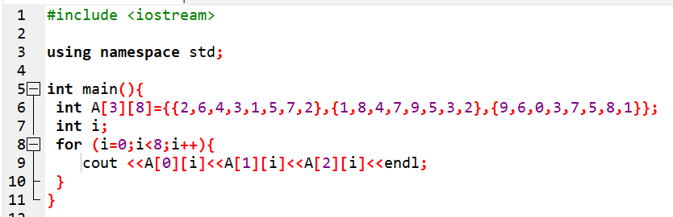

Jelaskan Hasil Output script Latihan 2.4.cpp di atas :

________________________________________________________________________  
________________________________________________________________________

________________________________________________________________________

________________________________________________________________________

________________________________________________________________________

________________________________________________________________________

**Latihan 2.5.cpp**

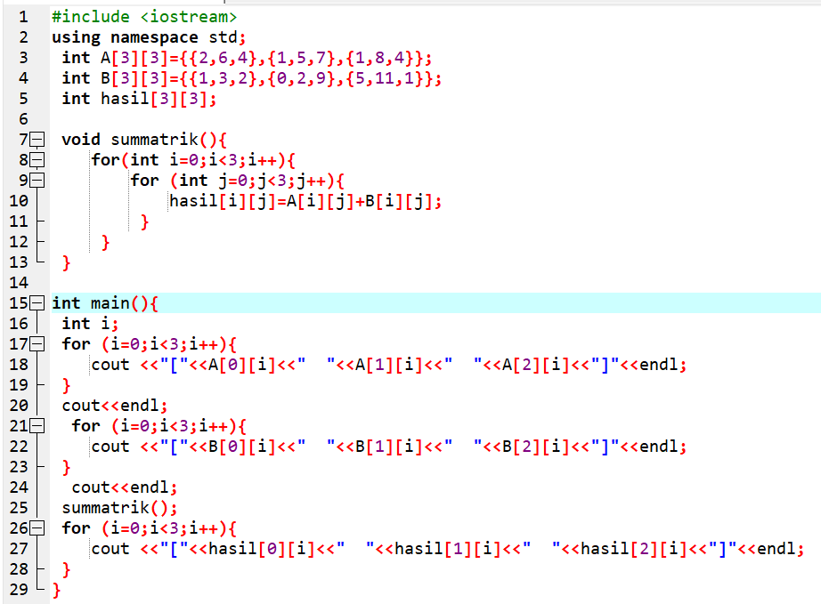

Jelaskan script Latihan 2.5.cpp di atas :

________________________________________________________________________  
________________________________________________________________________

________________________________________________________________________

________________________________________________________________________

________________________________________________________________________

Screenshoot Output Latihan 2.5.cpp

Jelaskan Hasil Output script Latihan 2.5.cpp di atas :

________________________________________________________________________  
________________________________________________________________________

________________________________________________________________________

________________________________________________________________________

# Tugas

Berdasarkan beberapa program di atas, buatlah program seperti berikut ini!

* + 1. Menentukan nilai jumlah dan rata-rata dari data di dalam array. Output seperti di bawah ini:

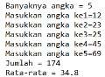

* + 1. Buatlah Program perkalian antar matrix ordo 4!

# Jawaban Tugas

# Jawaban No 1.

Screenshoot Script Soal 1.cpp

Jelaskan masing-masing baris script Soal 1.cpp di atas :

________________________________________________________________________  
________________________________________________________________________

________________________________________________________________________

________________________________________________________________________

________________________________________________________________________

________________________________________________________________________

________________________________________________________________________

# Jawaban No 2.

Screenshoot Script Soal 2.cpp

Screenshoot Output Soal 2.cpp

Jelaskan tentang script Soal 2.cpp di atas :

________________________________________________________________________  
________________________________________________________________________

________________________________________________________________________

________________________________________________________________________

________________________________________________________________________

________________________________________________________________________

________________________________________________________________________